Removing Goldbeter

The equations that define the Goldbeter set are described in Equations 1 to 3.

|  |  |  |
| --- | --- | --- |
|  | $$\frac{dZ}{dt} =v_{0}+v_{1}β-kZ -\frac{v_{m2}Z^{n}}{K_{2}^{n}+Z^{n}}+\frac{v_{m3}Y^{m}}{K_{R}^{m}+Y^{m}}∙\frac{Z^{p}}{K_{A}^{p}+Z^{p}}+k_{f}Y =L_{Z}$$ $$\frac{dY}{dt} =\frac{v_{m2}Z^{n}}{K_{2}^{n}+Z^{n}}-\frac{v_{m3}Y^{m}}{K_{R}^{m}+Y^{m}}∙\frac{Z^{p}}{K_{A}^{p}+Z^{p}}-k_{f}Y =L_{Y}$$ $$\frac{dV}{dt} =\frac{F.vol}{C_{m}}(v_{0}+v_{1}β-kZ ) =L_{V}$$ | (1)  (2)  (3) |

Then with diffusion added Equations 1 and 3 become 4 and 5 whilst there is no diffusion in Y.

|  |  |  |
| --- | --- | --- |
|  | $$\frac{dZ}{dt} =D\frac{d^{2}Z}{{dx}^{2}} + L_{Z}$$ $$\frac{dV}{dt} =\frac{F.vol}{C_{m}}D\frac{d^{2}V}{{dx}^{2}} + L_{V}$$ | (4)  (5) |

From here the goal is to remove terms until the propagation in the previously stable region no longer continues. The possible options to begin with are KfY, v0 or KZ terms individually from the two containing equations. Following negative results in these reducing the percentage of the parameters n and m to see their influence.

# Baseline Results

Results, including all terms, to compare to:

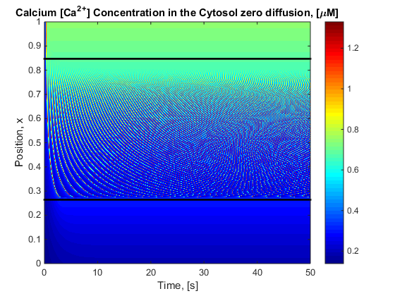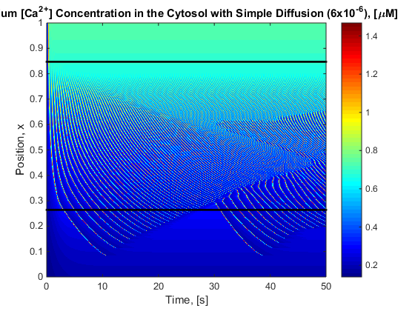

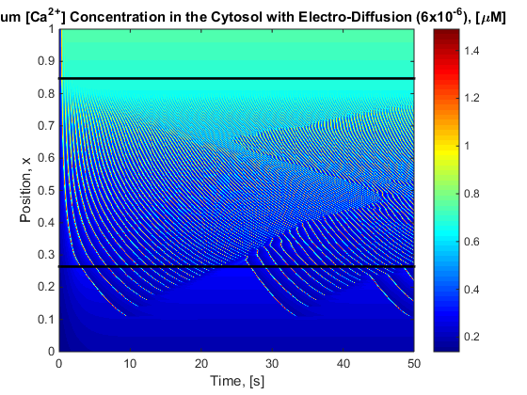

# Removing KfY term

For this problem computation time increased as there was a steeper gradient change between iterations. Due to the equations changing the stability region changed and thus did the bifurcation diagram. Propagation still occurred however appeared non-reducing.

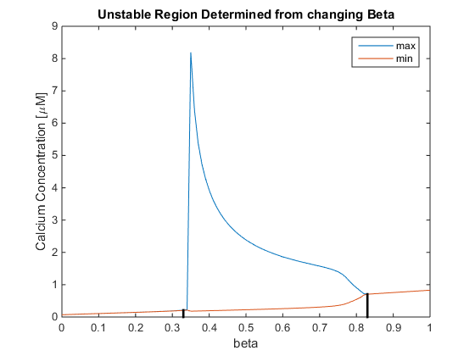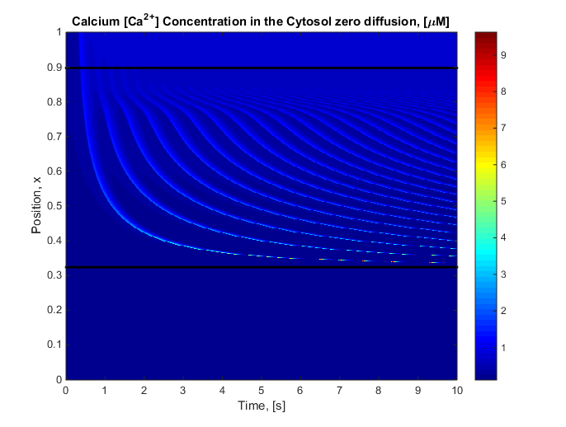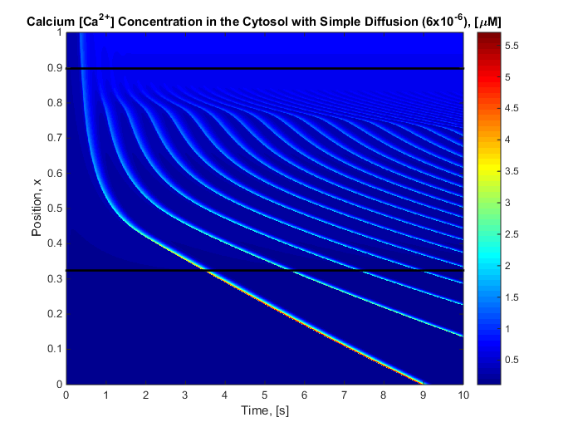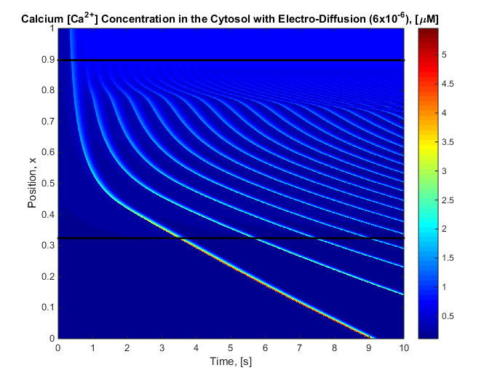

## 2.2 Reducing B further to try force stop

The bifurcation diagram is the same as before only now beta is linear over space and time has increased. Due to computational difficulties the time is stopped once computation time is increasing beyond reasonable per time step.

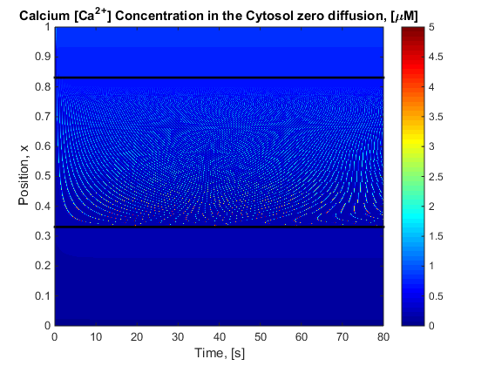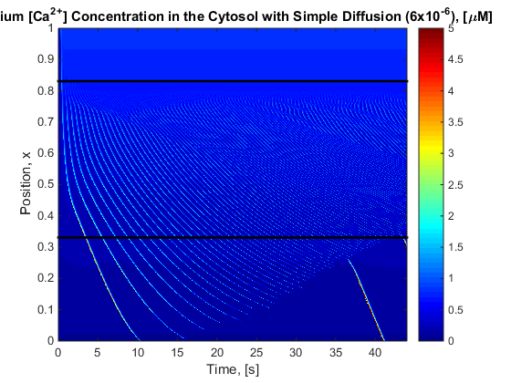

Note: the c axis is rescaled to see pattern ie 5 is not true max nor 0 true min.

From this can see the pattern remains even whilst removing KfY

# Removing the v0 term

Due to the equations changing the stability region moved as the v0 is just a scaling factor. Propagation still occurred and reduced.

# Removing the KZ term

This did not produce an occultation region which on further inspection of the equation makes sense. Removing the KZ term means that the cell was no longer removing the Ca2+ and thus steadily increased the concentration.

# Reducing the n,m,p percentage wise

Originally n=m=2 and p = 4. Starting with reducing n alone as it is connected with the simplest term in the goldbeter equations results are produced.

## Reducing n to 1

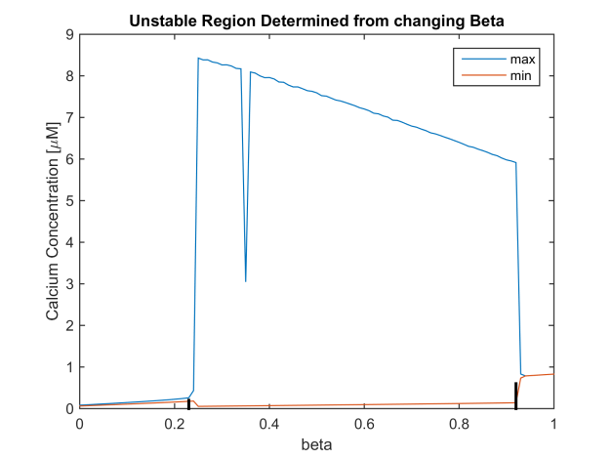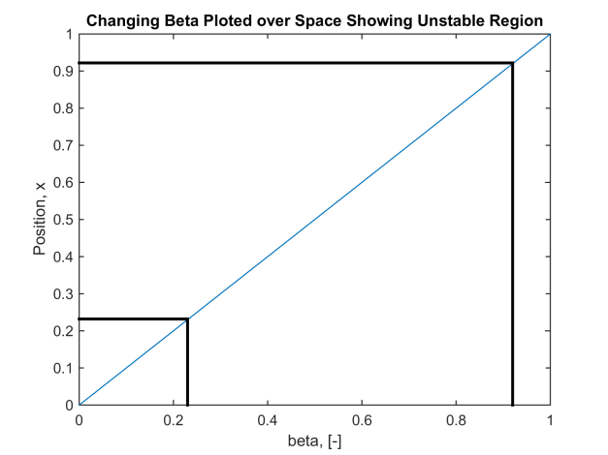

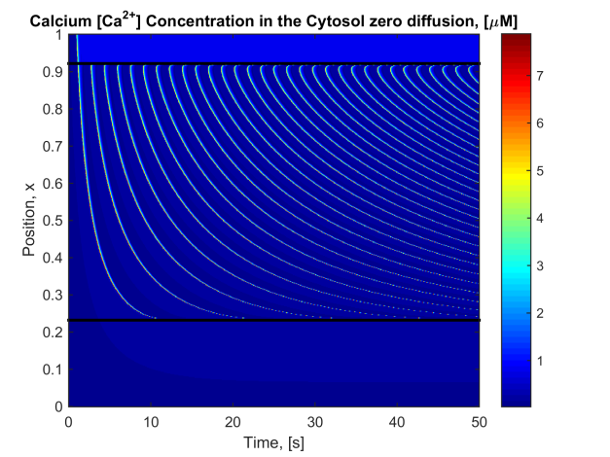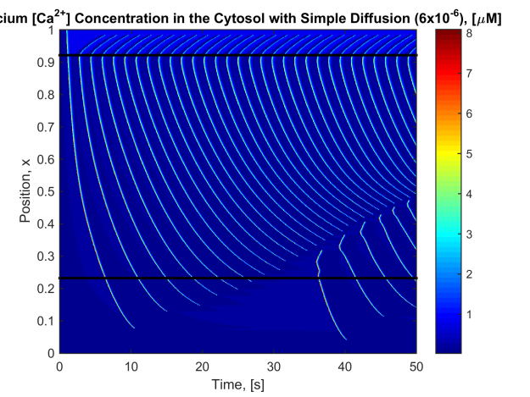

## Reducing n to 0

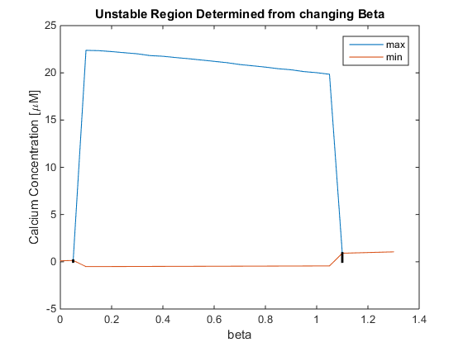

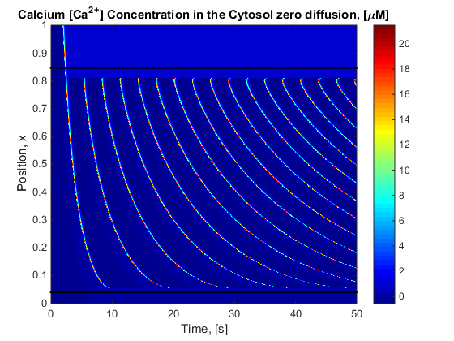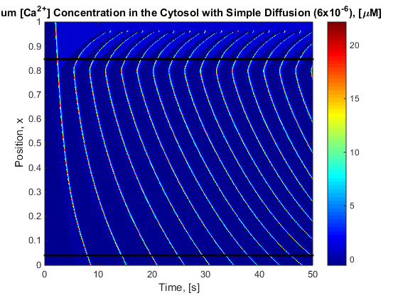

## Reducing m to 1

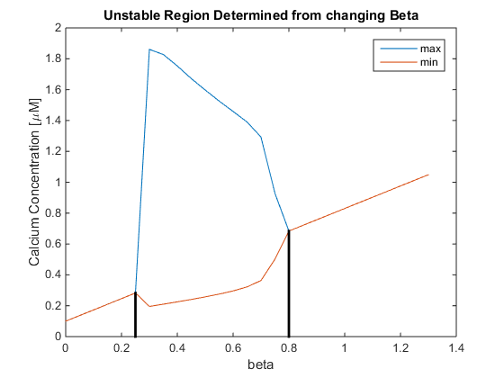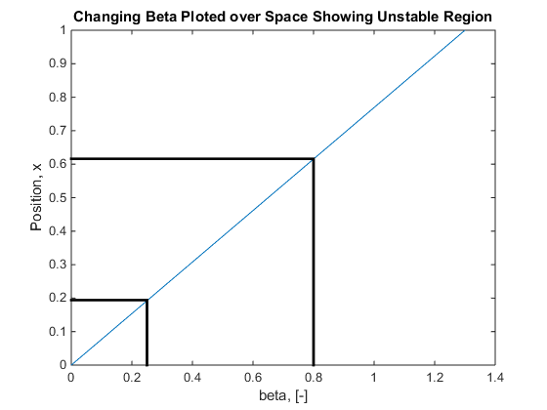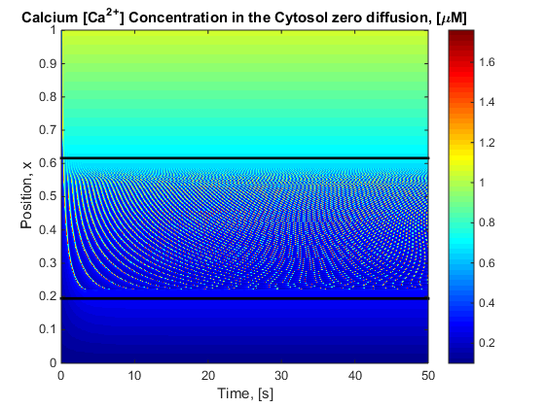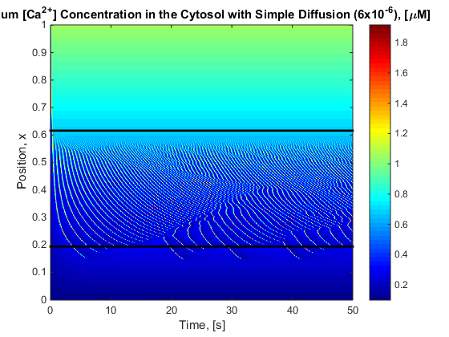

## Reducing m to 0

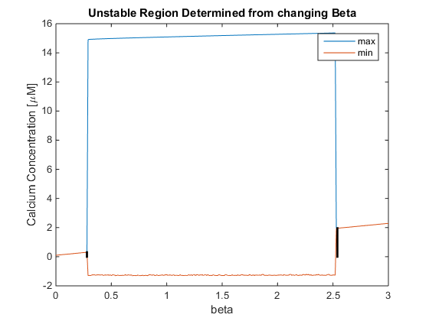 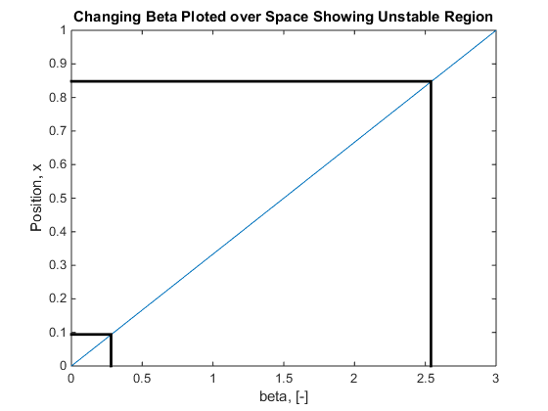 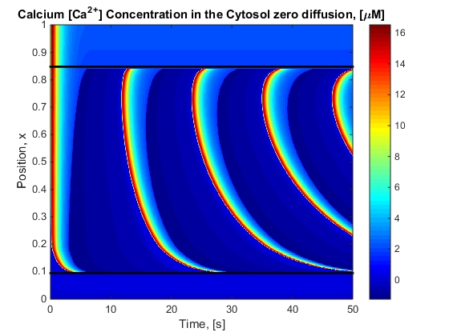 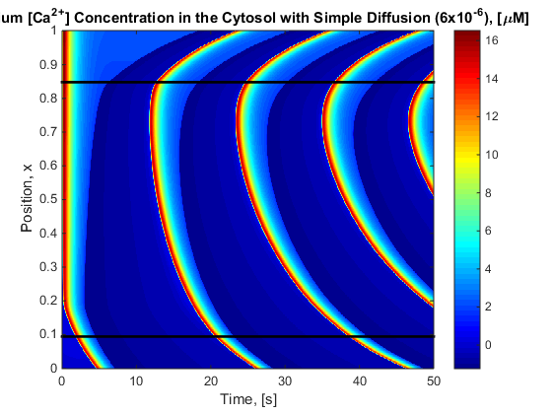

## Reducing p to 3

No stable oscillation’s occur (Dampening appears to occur)

## Reducing p to 2,1 or 0

No oscillatory region full stop.

y region full stop.

## Make p non integers 4<p<3

|  |  |
| --- | --- |
| P value | Result |
| 3.9 | Oscillation and propagation |
| 3.75 | Oscillation and propagation |
| 3.7 | Oscillation and small propagation |
| 3.65 | Oscillation and minor propagation |
| 3.64 | Oscillation and no propagation |
| 3.625 | Oscillation and no propagation |
| 3.6 | Oscillation and no propagation |
| 3.5 | Oscillation and no propagation |
| 3.4 | Oscillation and no propagation |
| 3.2 | Oscillation and no propagation |
| 3.6 | Oscillation and no propagation |
| 3.5 | Oscillation and no propagation |

# Results Summarised

|  |  |  |  |
| --- | --- | --- | --- |
|  | M | N | P |
| 0 | Reduced propagation | Propagation | No Oscillation’s |
| 1 | Propagation | Propagation | No Oscillation’s |
| 2 |  |  | No Oscillation’s |
| 3 |  |  | No stable Oscillation’s |
| 3.5 |  |  | Oscillation, no propagation |
|  |  |  |  |

# Discussion

Removing the leak term from the store to the cytosol does not affect propagation or unusual pattern.